 深圳市永亿豪电子有限公司
APPROVAL SHEET

Customer:
Customer P/N:
SNOWFAN Model NO.: YE25489M110
SNOWFAN P/N:
Version.: 0 Sample NO.:
Issue date: Quantity: 0 PCS
*Please sign back this specification for our record upon your approval. Thanks!
Company  Stamp |  | Customer approval  Stamp
制作：程 梅 |  | 承认：
复核：曾睿君 |  | 核准：
核准： |  | 日期：

地址:深圳市龙华新区观澜街道福民茜坑新村佰公坳工业区二巷10号厂房电话：28035708 传真：28035808
http://www.snowfan.com.cn/ E-Mail: yongyihao@snowfan.com.cn

版次 | 变更履历 | 日期
A | 新版发行 | 2019.7.29

1.0一般规格（General Specification)
项目 Item |  | 规格/条件Specification/Condition
1 | 型号Mode1 No. | YE25489M110
2 | 外型尺寸 Outline. Dimension | 254*89mm
3 | 工作电压 Operating Voltage | AC 80～135V
4 | 额定电压Rated .voltage | AC 110V
5 | 启动电压Starting Voltage | AC ≤80V on/off
6 | 消耗功率 Power consumption | 55W （Max：60W） | a. 额定电压Rated .voltage  b.25℃ 65% RH  c.After testing for 5 minutes
7 | 转速 Speed | 2550±10%RPM
8 | 风量Airflow AT ZERO STATIC PRESSURE | 739CFM(Min:665CFM) | a. 额定电压Rated .voltage  b. AMCA标准Standard  C. 额定电流Rated current
8 | 静压Air .Static Pressure AT ZERO AIRFLOW | 21.66mmH2O  (Min.：19.44mmH2O)
9 | 噪音标准Noise Level | 66dB-A(Max:69dB-A) | a. 额定电压 Rated Voltage  b. 18dB无响室 18dB Non-Echo Chamber  c. 标准 Standard: CNS 8753 / ISO 3744  d. Test Condition :ISO 7779  e. 距离 Distance: 1.0 M
10 | 期望寿命Life expectancy | 70000 hrs at temp40℃ Humidity5%～95% | MTTF Mean Time To Failure  Conf. Level 90%
11 | 扇叶数No.of.Blade | 3叶
12 | 极数 No.of.Pole | 6极
13 | 运转方向Rotating Direction | 顺时针/运转方向是从标签面看
14 | 锁住保护Lock Protection | 1.额定电压下堵住2～3秒,风扇自动断电,停止运转, 降低内部温升  Auto power off after locked at rated voltage for 2～3 sec. Reduce internal temperature rise  2.风扇停转后,风扇会在2至6秒自动尝试启动  After auto power off, circuit attempt to restart in 2 to 6 sec.
15 | 极性保护Polarity Protection | 无 NO
16 | 过压保护 Over voltage protelt | 无 NO
17 | 过流保护Over current protection | 无 NO
18 | 恒速功能fixed constant speed Function | 该风扇电机的程序可以运行在一个预先设定的转速 超过设定电压而其速度保持不变 最大电源电压要在工作范围内  The fan motor can be run at a predetermined speed, exceeds the set voltage, and its speed is constant, the maximum supply voltage to be within the scope of work in
19 | 软启动Soft Starting | 当给风扇供电,风扇的电流是从零开始逐渐增加 直到达到其最高转速  和额定电流  When the power switch is turned on to supply current to the fan, the current is zero and starts to increase gradually until the fan has achieved its maximum speed and the rated current
20 | PWM功能 PWM function | 通过输入一个PWM占空比信号控制风扇转速.  Enter a PWM duty cycle signal to control fan speed
21 | PQ曲线 PQ curve | 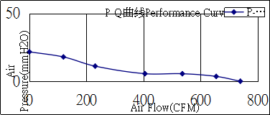
2.0:主要材料/零件规格（Main Materials/parts Specification）
材料/零件  Materials/parts |  | 规格  Specification
1 | 塑料材料/ 外框扇叶  Plastic Material/ Frame impeller | 黑色PBT 3叶 防火等级94V-0
1 | 塑料材料/ 外框扇叶  Plastic Material/ Frame impeller | 铝圆框
2 | 轴承  Bearing Type | 滚珠轴承  Ball Bearing
3 | 引线  Lead Wire | 电缆线剥皮外露棕蓝（黄绿）+蓝红白黄分线
4 | 端子  Connector | 无端-7P
4 | 端子  Connector | 棕 | 蓝 | 黄绿 | 蓝 | 红 | 白 | 黄
4 | 端子  Connector | L | N | 地线 | GND | VCC | FG | PWM/VC
5 | 环保要求  EnvironmentalRequirement |  |  | 永亿豪环保  标准
3.0电性规格（Electrical Specifically）
1 | 绝缘阻抗  Insulation Resistance | 10MΩ/裸线与外框间测量，500VDC/min  10MΩ/between unshackled wire and frame at  500VDC/min
2 | 绝缘耐压  Dielectric Strength | 10Ma Max./导线与外框间测量，1500VAC/min  10Ma Max./Measured between lead wire(+)and frame at 1500VAC/min
3 | 防水等级  Waterproof level | IP44
4.0环境测试（Environmental Specification）
1 | 运转温/湿度范围  Operating Temp .Range | 温度/Temperature:-10℃～+70℃  湿度/Humidity:5%～95%RH
2 | 保存温/湿度范围  Storage Temperature | 温度/Temperature:-40℃～+75℃  湿度/Humidity:5%～95%RH
3 | 耐湿性  Humidity | 电气规格依据MIL-STD 202F Method 103B  湿度：95%RH 温度：40±2℃
4 | 热冲击  Thermal Shock | 电气规格依据MIL-STD 202F Method 107D  Per MIL-STD 202F Method 107D,Condition D
5 | 绝缘阶段  Insulation Shock | UL: A级  UL：Class A
6 | 包装耐振动试验  Packing Vibration Test | 包装后，XYZ三方向施3.2G load vibration test for 30min .No serious damage
7 | 包装耐冲击试验  Packing Shock Proof Test | 捆包后，高60公分，1棱角3边6面自然落下，无严重损坏.  1comer,3edges, 6faces natural drop from 60cm high packing No serious damage

5.0在无响室额定电压下之噪音测试
（Noise is measured at rated voltage in anechoic）
（在背景噪音不超过18dB（A）的无响室内，将待测风扇通入额定的工作电压，悬掉入空中，将麦克风放于风扇同一平面且离待测风扇进风口一米处进行测试其 B&K 值）
Noise is measured rated voItage in free air in anechoic chamber with B&K sound IeveI meter with microphone at a distance of one meter from the fan intake.The background noise is 18Db(A) max。

Function type is optional.

6.0信号及波形（Frequency Generator 0/P）

6.1信号测试方式（Frequency test mode）

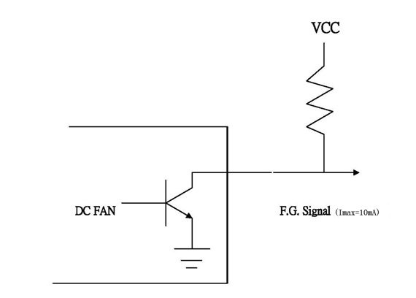

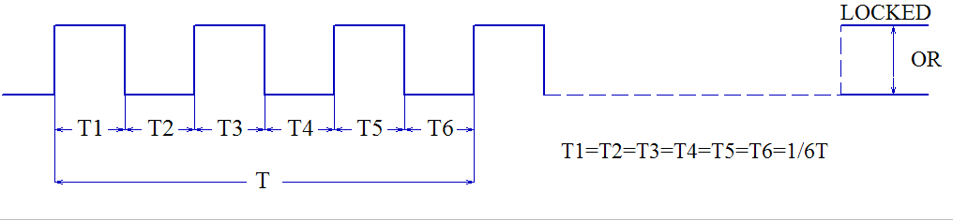

7.0 PWM信号（PWM Signal）

7.1 风机PWM信号内部接口电路(频率300HZ~3KHZ)

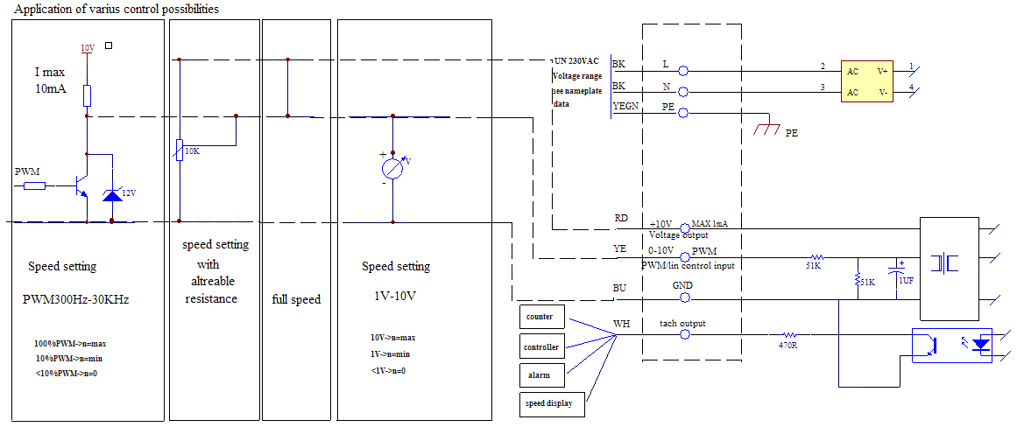
7.2转速与PWM/VC控制信号
7.21PWM控制信号(Speed VS PWM control signal) (At 220V T=25℃ f=1kHZ )

占空比（%/） | 0% | 20% | 50% | 100%
转速（RPM） | 0 | 500±200RPM | 1250±200RPM | 2550±10%RPM

备注：使用PWM调速时，PWM高电平幅值为10V
7.22 VC控制信号(Speed VS VC control signal) (At 220V T=25℃ )

电压（V） | 0V | 2V | 5V | 10V
转速（RPM） | 0 | 500±200RPM | 1250±200RPM | 2550±10%RPM

注意事项（NOTES）
1 Before use, make sure the supply voltage to meet the use of the product range, line-powered load exceeds the maximum power consumption of this product 120%. And the voltage is stable without clutter
（使用前，确认供电电压能满足本产品的使用范围，供电电路负载超过本产品的最大功耗的120%。且电压是稳定不含杂波干扰）
2 Please when ventilator circular telegram normal work do not use the hand to bump touches fan blade border
（请在风扇通电正常运转时不要用手碰触扇叶边沿）
3 Please do not touch the impeller and never carry the fan the lead wires.The bearings and the lead wires may be damaged. Additionally, static electricity may damage the intemal ciruits of the fan
(请不要碰触扇叶和拉扯线材，以免损坏轴承及导线。此外,静电可能损坏内部的风扇组件)
4 Please do not use the fan in the environment of corrosive gas or liquid.
（请不要将风扇置于腐蚀的气体和液体内）
5 Please do not store the an in the environmet of high humidity.Please avoid storage of the fan over 6months.For long term storage, please connect power to the fan shortly every 6 months even through the fan is stored in room temperature.
（请不要将风扇储存在高湿度的环境中，请尽量避免将风扇储存期超过6个月。如果要长期储存，请将其在室温的环境下。且每隔6个月须上电源让风扇短时间运转。）

